Transformations and Complex Numbers
Abstract
In this paper, we use complex-number operations to carry out transformations of geometric shapes and establish connections between geometry and algebra in the high-school curriculum. We use dynamic geometry software to visualize the geometric effect of these algebraic operations and connect complex-number operations to translations, rotations, and dilations.
Keywords: GeoGebra; Common Core; Complex Numbers; Algebra; Geometry; Transformations
1 Introduction
Students typically encounter complex numbers when solving quadratic equations, ${ax}^{2}+bx+c=0.$ For instance, applying the quadratic formula, $x = \frac{-b±\sqrt{b^{2}-4ac}}{2a}$, to ${3x}^{2}+x+5=0$, they determine that the discriminant, $b^{2}-4ac = -59,$ is negative. Many times, students are told “they cannot take the square root of a negative number.” Later on, students learn that it is possible to take the square root of a negative number and, in particular, $i= \sqrt{-1}$, or equivalently $i^{2}=1$. We call i an imaginary or complex number. A complex number is of the form $z=a+bi$, where a and b are real numbers and i satisfies $i^{2}=1$. The Complex Number System appears in the Common Core State Standards for Mathematics (CCSS-M) in Number and Quantity, High School. Students learn to perform complex number operations and represent addition, subtraction, multiplication, and conjugation of complex numbers geometrically on the complex plane (CCSS. Math.Content.HSN.CN.B.5). In this paper, we use these complex-number operations to carry out transformations of geometric shapes. We seek to establish connections between geometry and algebra in the high-school classroom. During our discussion, we use the dynamic geometry software, GeoGebra (Hohenwarter, 200x) to visualize the geometric effect of these algebraic operations. We start by providing some historical comments on complex numbers. Next, we connect each complex-number operation with a geometric transformation. We conclude the paper with reflections on our work with teachers and students.
2 Historical Notes on Complex Numbers
Many have written about the solution of the cubic equation and our historical notes stem from Dunham’s work (1990). Historically, Gerolamo Cardano’s (1501-1576) work on the solution of the general cubic equation helped to give complex numbers a legitimate place. Cardano solved the general cubic equation, $x^{3}+ px^{2}+qx + r=0$ in 1545 by using the substitution $z =x- \frac{p}{3}$to eliminate the quadratic term, thus obtaining a “depressed” cubic, $z^{3}+bz +c = 0$. Next, he applied the formula obtained from Niccolo Fontana (1500-1557) to solve the depressed cubic. Scipione del Ferro (1465-1526) had also derived this formula 30 years earlier but had not published it. Both Fontana and del Ferro showed that one of the solutions of$x^{3}+bx +c = 0$ is given as
$$x = \sqrt[3]{-\frac{c}{2}+\sqrt{\frac{c^{2}}{4}+\frac{b^{3}}{27}}} - \sqrt[3]{\frac{c}{2}+\sqrt{\frac{c^{2}}{4}+\frac{b^{3}}{27}}}$$
In particular, when Cardano solved polynomials such as $x^{3}-6x+4=0,$ we see that the solution given by the formula is $x=\sqrt[3]{-2+\sqrt{-4}}-\sqrt[3]{2+\sqrt{-4}}$. We can visually inspect the cubic polynomial and note that $x=2$ is a solution and use algebra to show that the two other solutions are $x=-1±\sqrt{3}$. Thus the number
$$\sqrt[3]{-2+\sqrt{-4}}-\sqrt[3]{2+\sqrt{-4}}$$corresponds to one of these solutions but at the time complex numbers were not fully understood, nor did most mathematicians spend time on them. In fact, after investigating complex numbers for a bit Cardano dismissed understanding complex numbers as being useless.
In 1572, Bombelli (1526-1572) made the first major breakthrough regarding complex numbers in his treatise, Algebra. He decided to investigate the cubes of the numbers such as $1+\sqrt{-1}$ and $-1+\sqrt{-1}$. Note that
$${\left(1+\sqrt{-1}\right)}^{3}=1+3\sqrt{-1}+3{\left(\sqrt{-1}\right)}^{2}+{\left(\sqrt{-1}\right)}^{3}=-2+\sqrt{-4}.$$Similarly we can show that ${\left(-1+\sqrt{-1}\right)}^{3}=2+\sqrt{-4}$, thus
$$\sqrt[3]{-2+\sqrt{-4}}-\sqrt[3]{2+\sqrt{-4}}=\sqrt[3]{{\left(1+\sqrt{-1}\right)}^{3}}-\sqrt[3]{{\left(-1+\sqrt{-1}\right)}^{3}} \\ =1+\sqrt{-1}+1-\sqrt{-1}=2$$ Thus, as Cardano would have put it, 2 was “disguised” as $\sqrt[3]{-2+\sqrt{-4}}-\sqrt[3]{2+\sqrt{-4}}.$ Yet it would be another two centuries before Euler, Gauss, and Cauchy made it evident that complex numbers were an important and vital part of the mathematical landscape. In the next sections, we discuss how complex- number operations are related to geometric transformations. We start with complex-number addition and their relationship to translations.
3 Connecting Addition with Translations in the Complex Plane
Students usually understand that to translate a point in the plane horizontally, they need to add or subtract a number from the x-coordinate of the point. Similarly, to translate a point in the plane vertically, students will add or subtract a number from the y-coordinate. This idea parallels operations with complex numbers. We begin by exploring how the operations of addition and subtraction are represented in the complex plane. Next, we discuss a more general case of transformations of a plane.
Take two complex numbers, say $z_{1}=1+2i$ and $z_{2}=4+i$ (Note: To type $z_{1}$ in GeoGebra we enter z_1 in the Input box at the bottom of the screen.) The Algebra View displays them in symbols while the Graphics Views shows them as points (Figure 1).
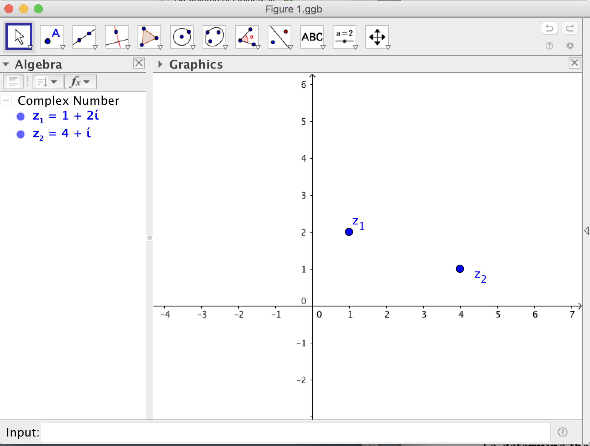
Figure 1 Representing complex numbers on the plane.
To determine the sum of the two complex numbers $z_{1}$ and $z_{2}$, we enter $z_{3}=z_{1}+z_{2}$ in the Input box. The software automatically displays the sum $z_{3}$ with a label on the complex plane (Figure 2).
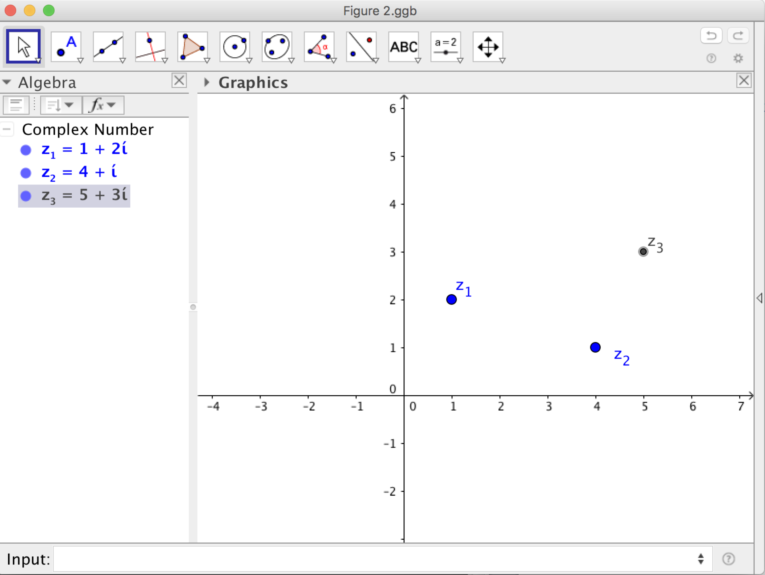
Figure 2 The sum of $z_{1}$ and $z_{2}$ represented in the complex plane.
We now observe the geometry of adding two complex numbers. In Figure 3 we formed a quadrilateral by connecting the four complex numbers, $z_{0, } z_{1},{ z}_{2},$ and $z_{3}$, where $z_{0, }$ is the complex number 0 + 0i. Readers can recognize that the sum of complex numbers is related to vector addition, where the sum of the vectors corresponding to (1, 2) and (4, 1) is the vector (5, 3) and the quadrilateral is a parallelogram. Thus we can see how complex numbers provide a geometric connection to vector addition since $\left(1+2i\right)+\left(4+i\right)=\left(1+4\right)+\left(2i+i\right)= 5+3i$. Figure 3 also shows in the Algebra panel the length of each segment connecting two complex numbers denoted by $l_{1},l_{2}, l_{3}$, etc. and we observe that the opposite sides of the quadrilateral are congruent thus the quadrilateral is a parallelogram. We label the lengths of each segment in the Graphics panel using modulus notation. The modulus of a complex number, $a+bi$, $\left|a+bi\right|=\sqrt{a^{2}+b^{2}},$ is the distance of the complex number to the origin. The importance of the modulus will be discussed in the section on multiplication and division of complex numbers.
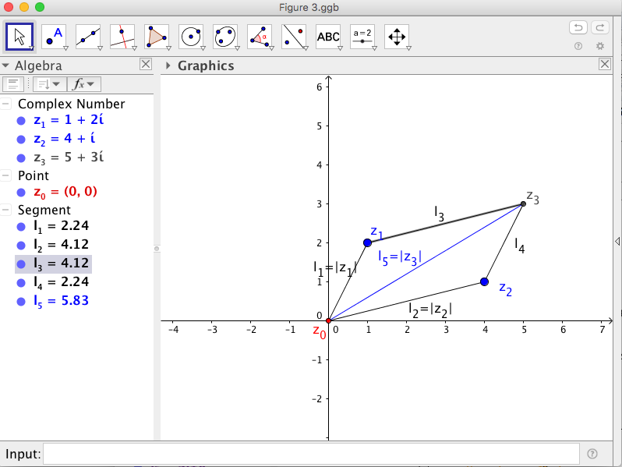
Figure 3 Algebraic and geometric sum of complex numbers.
Similarly, to determine the difference of the same complex numbers $z_{1}$ and $z_{2}$, we enter in the input box, $z_{4}=z_{1}-z_{2}$. The software automatically displays the difference with a label on the complex plane and we used a different color (right click on the object and scroll down to Properties – this will open a box that will allow you to color the object) when drawing the segment from the origin to $z_{4}$ to distinguish this segment from the others (Figure 4). We also computed the difference $z_{5}=z_{2}-z_{1}$. This segment is also distinguished with a different color. Note that $l_{6}=|z_{4}|$ and $l_{7}=\left|z_{5}\right|$.
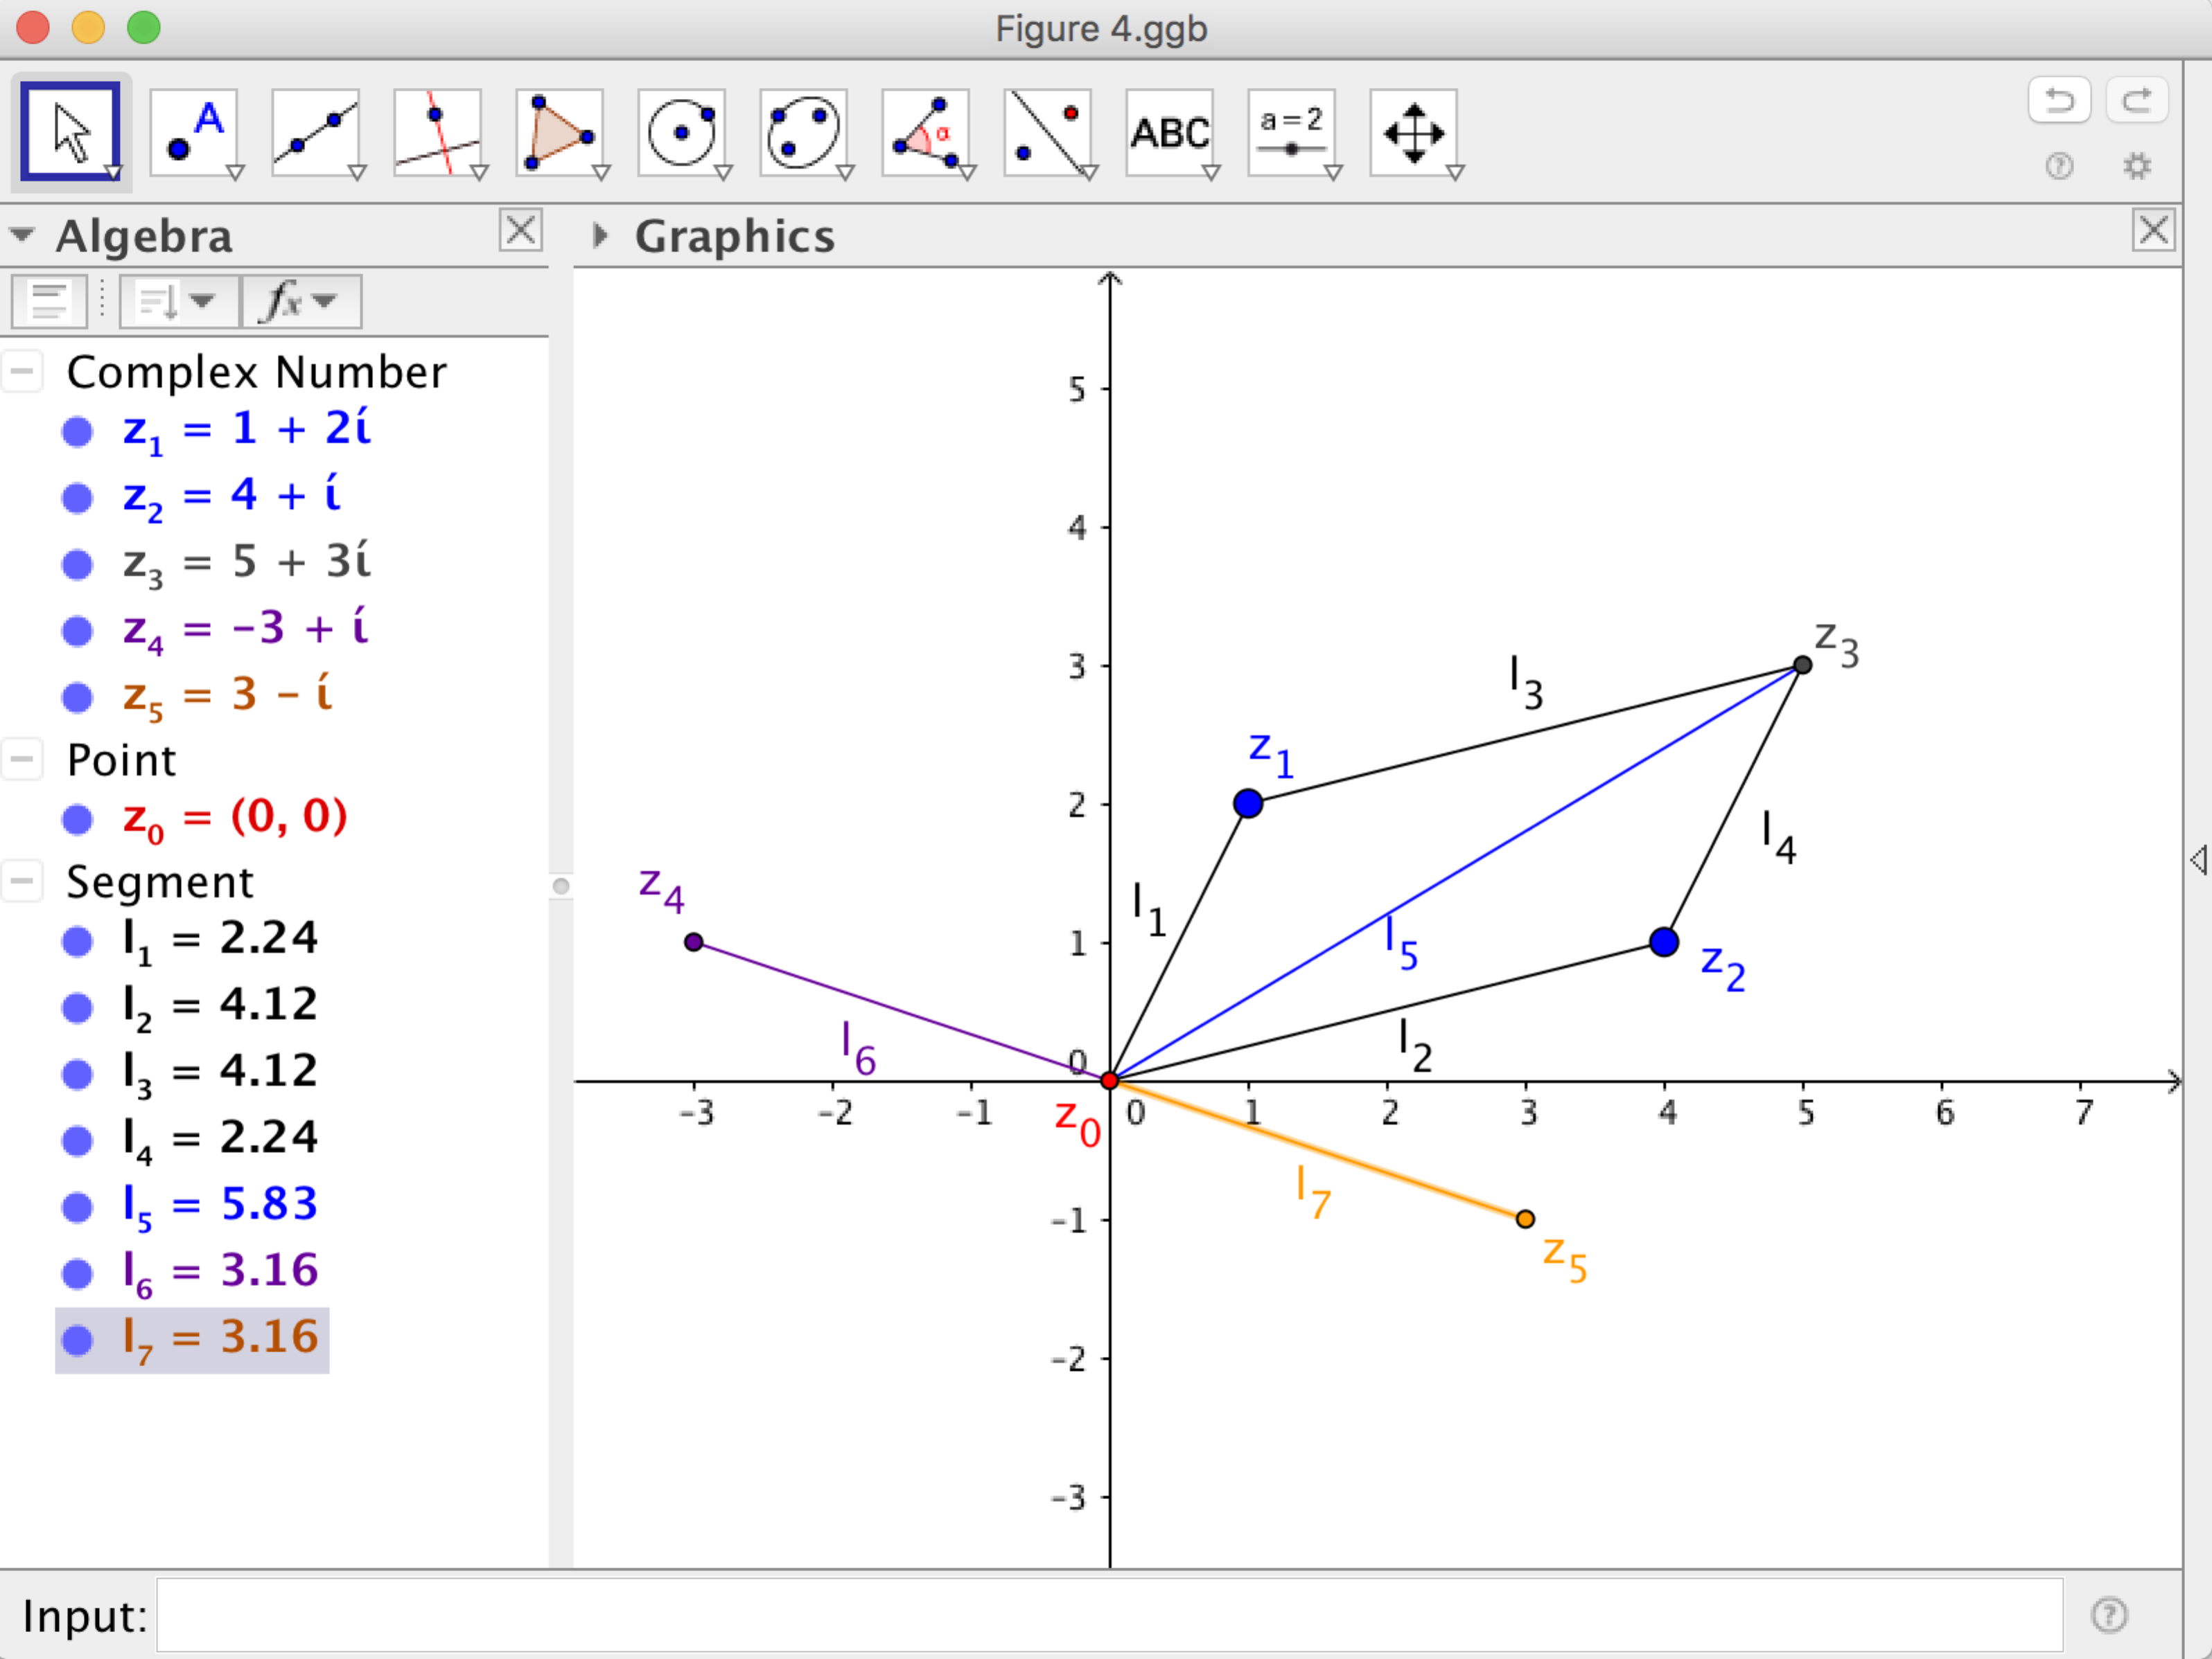
Figure 4 Algebraic and geometric difference of complex numbers.
We briefly comment that the difference of two complex numbers is related to the Triangle Midsegment Theorem. Thus if we connect $z_{4}$ to $z_{1}$, $z_{5}$ to $z_{2}$, and $z_{1}$ to $z_{2}$, with segments $l_{8},l_{9},$ and $l_{10}$, respectively, we observe that the segments $l_{6},l_{7},$ and $l_{10}$ are congruent (Figure 5).
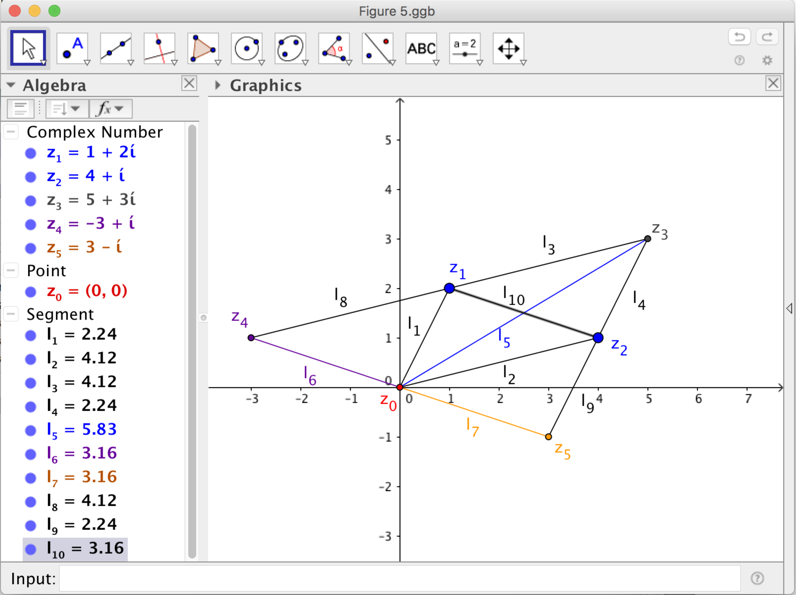
Figure 5 An illustration of the Triangle Midsegment Theorem with complex numbers.
One last note about subtraction – indeed the simplest way to think of subtraction of two complex numbers is that the opposite of the second complex number is being added to the first. In other words
$$z_{4}=z_{1}-z_{2}=z_{1}+\left(-z_{2}\right).$$
Note that this also coincides with how we explain vector subtraction, giving us yet another connection between algebra and geometry. We invite readers to drag complex numbers $z_{1}$ or ${ z}_{2}$, and observe how the parallelogram changes. As you do so, reflect on the connections to vector addition and subtraction. In the next section, we use complex numbers to translate graphs of functions in the software.
4 Using Complex-Number Addition to Translate a Graph
Remember that a complex number $a+bi$ corresponds to the point (a, b) in the complex plane. We shall see that this will be a very useful representation as we continue exploring. We can graph a function, say $f\left(x\right)=x^{2}$, by plotting the points $(x,f\left(x\right))$, that is we conceptualize the function as a mapping from the real numbers to the real numbers, but we interpret the inputs as the real part of the imaginary number $x+i x^{2}$ and the outputs a the imaginary number $x+i x^{2}$. We thus produce the graph of the function $f\left(x\right)=x^{2}$ but in the complex plane. To translate the graph of the function we shift each of the points on the graph. For example, to shift one unit to the right and two units up, we add one unit to the x-value and two units to the y-value, thus obtaining points of the form $(x+1,f\left(x\right)+3)$. We can use the tools in the software to shift the graph of a function as described above. First, graph $f\left(x\right)=x^{2}$ by typing $f\left(x\right)=x^{2}$ in the Input box (see Figure 6). Then, construct a point A on the graph of $f\left(x\right)$ using the Point tool. Note that the software uses the notation (x(A), y(A)) to describe the point A on the graph of $f\left(x\right)=x^{2}$. Next, construct another point B on the plane. This point has coordinates (x(B), y(B). Define in the Input box a point C as $C=\left(x\left(A\right)+x\left(B\right), y\left(A\right)+y\left(B\right)\right).$We drag the point A using the Move tool (pointer) and see the effect on the point C, the translation of A by the point B.
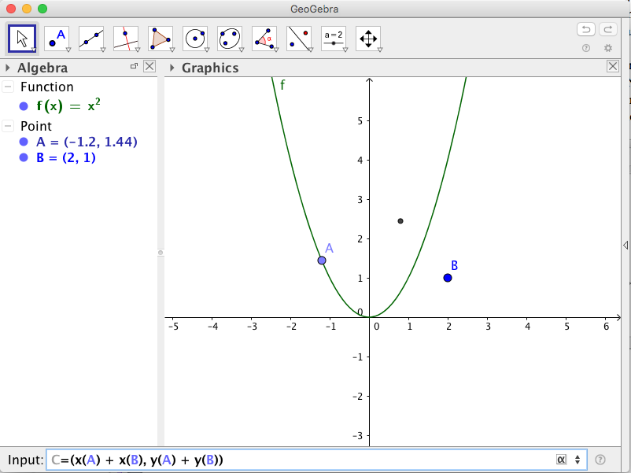
Figure 6 Constructing a translation of point A on the graph of f(x).
Next, we use another dynamic geometry software tool, Locus (on the 4th button from the left), to produce the result of shifting the whole graph. The software provides directions on how to use this tool (see Figure 7). We first select the point C, then point A, and the software provides the resulting graph (see Figure 8). We invite readers to drag the entire graph of f(x), or the point B, using the Move tool and reflect on the horizontal and vertical translations given by the coordinates of the point B. Furthermore, we can easily redefine $f(x)$ by simply typing another function in the Input Box. For instance, try a “depressed” cubic such as $f\left(x\right)=x^{3}-x-1$. Notice that it has one real solution and two complex solutions. We now shift our focus to discuss the connections between the operations of multiplication and division of complex numbers with rotations and dilations of the plane.
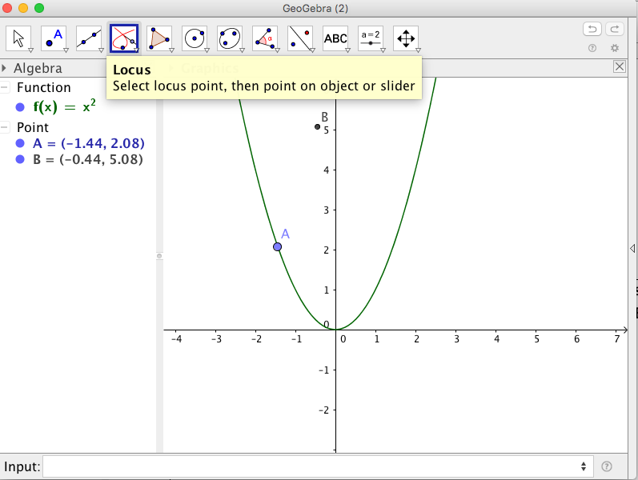
Figure 7 Locus command on GeoGebra.
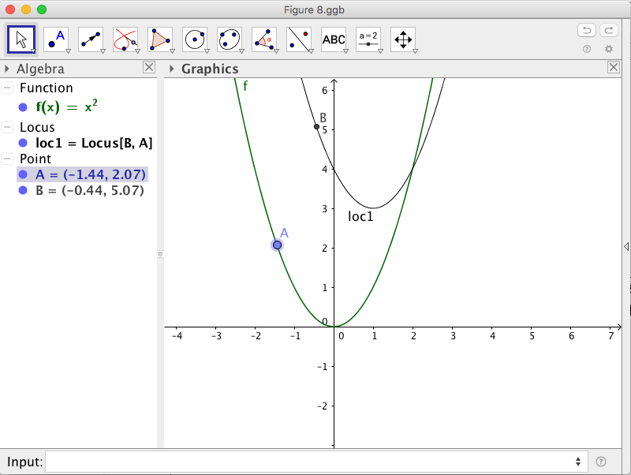
Figure 8 Translation of the graph of $f\left(x\right)=x^{2}$.
5 Connecting Multiplication and Division with Transformations in the Complex Plane
We start our discussion with a particular situation – consider the complex number $z_{1}=1+2i$ and multiply it by the complex number $z_{2}=0+i$. Enter both of them in the Input box remembering the notation we introduced in the previous sections. To obtain the product of these two complex number we type z_3 = z_1 * z_2 in the Input box. See the resulting product in Figure 9. Note the relationship between $z_{1}$ and $z_{3}$: it appears that $z_{3}$ is the point obtained by rotating $z_{1}$ 90° counterclockwise about the origin. If you need extra data to make this conclusion, drag the complex number $z_{1}$ and observe the position of $z_{3}$. We suggest you consider the coordinates of both $z_{1}$ and $z_{3}$.
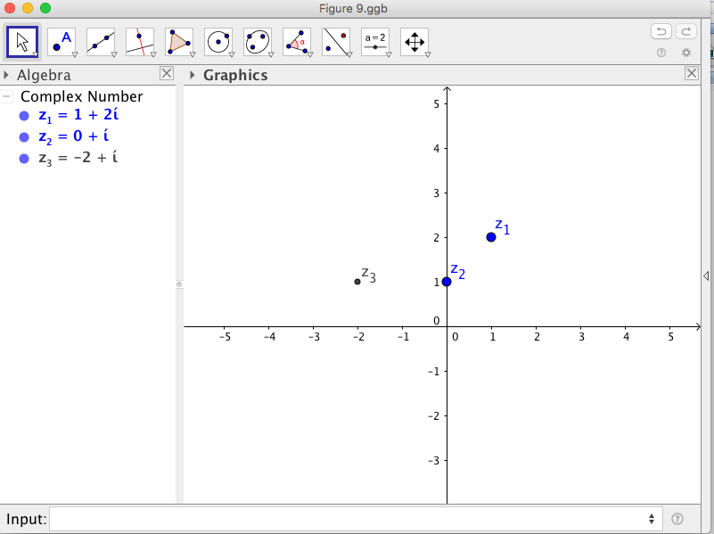
Figure 9 Multiplication of a complex number by i.
We now focus on changing $z_{2}$. Consider the effect of multiplying by $z_{2}=0+2i$ instead. In other words, we translate $z_{2}$ one unit up vertically. In this case, $z_{3}$ is the product of $z_{1}$ by 2i. Before continuing consider the following question What is similar and what is different than multiplying by the number i? You are on the right track if you thought that $z_{3}$ is again a 90° counterclockwise rotation of $z_{1}$ about the origin. However, somehow $z_{3}$ has also shifted away from the origin (see Figure 10). How far is $z_{3}$ from the origin and how can we determine this using what we know about $z_{2}$? If we compare the moduli of $z_{1}$ and $z_{3}$, we note that $\left|z_{3}\right|=2∙|z_{1}|$. Before continuing, drag $z_{1}$ to points where you can focus on its coordinates. Next, consider the question Would a similar situation occur if we continue moving $z_{2}$along the y-axis?
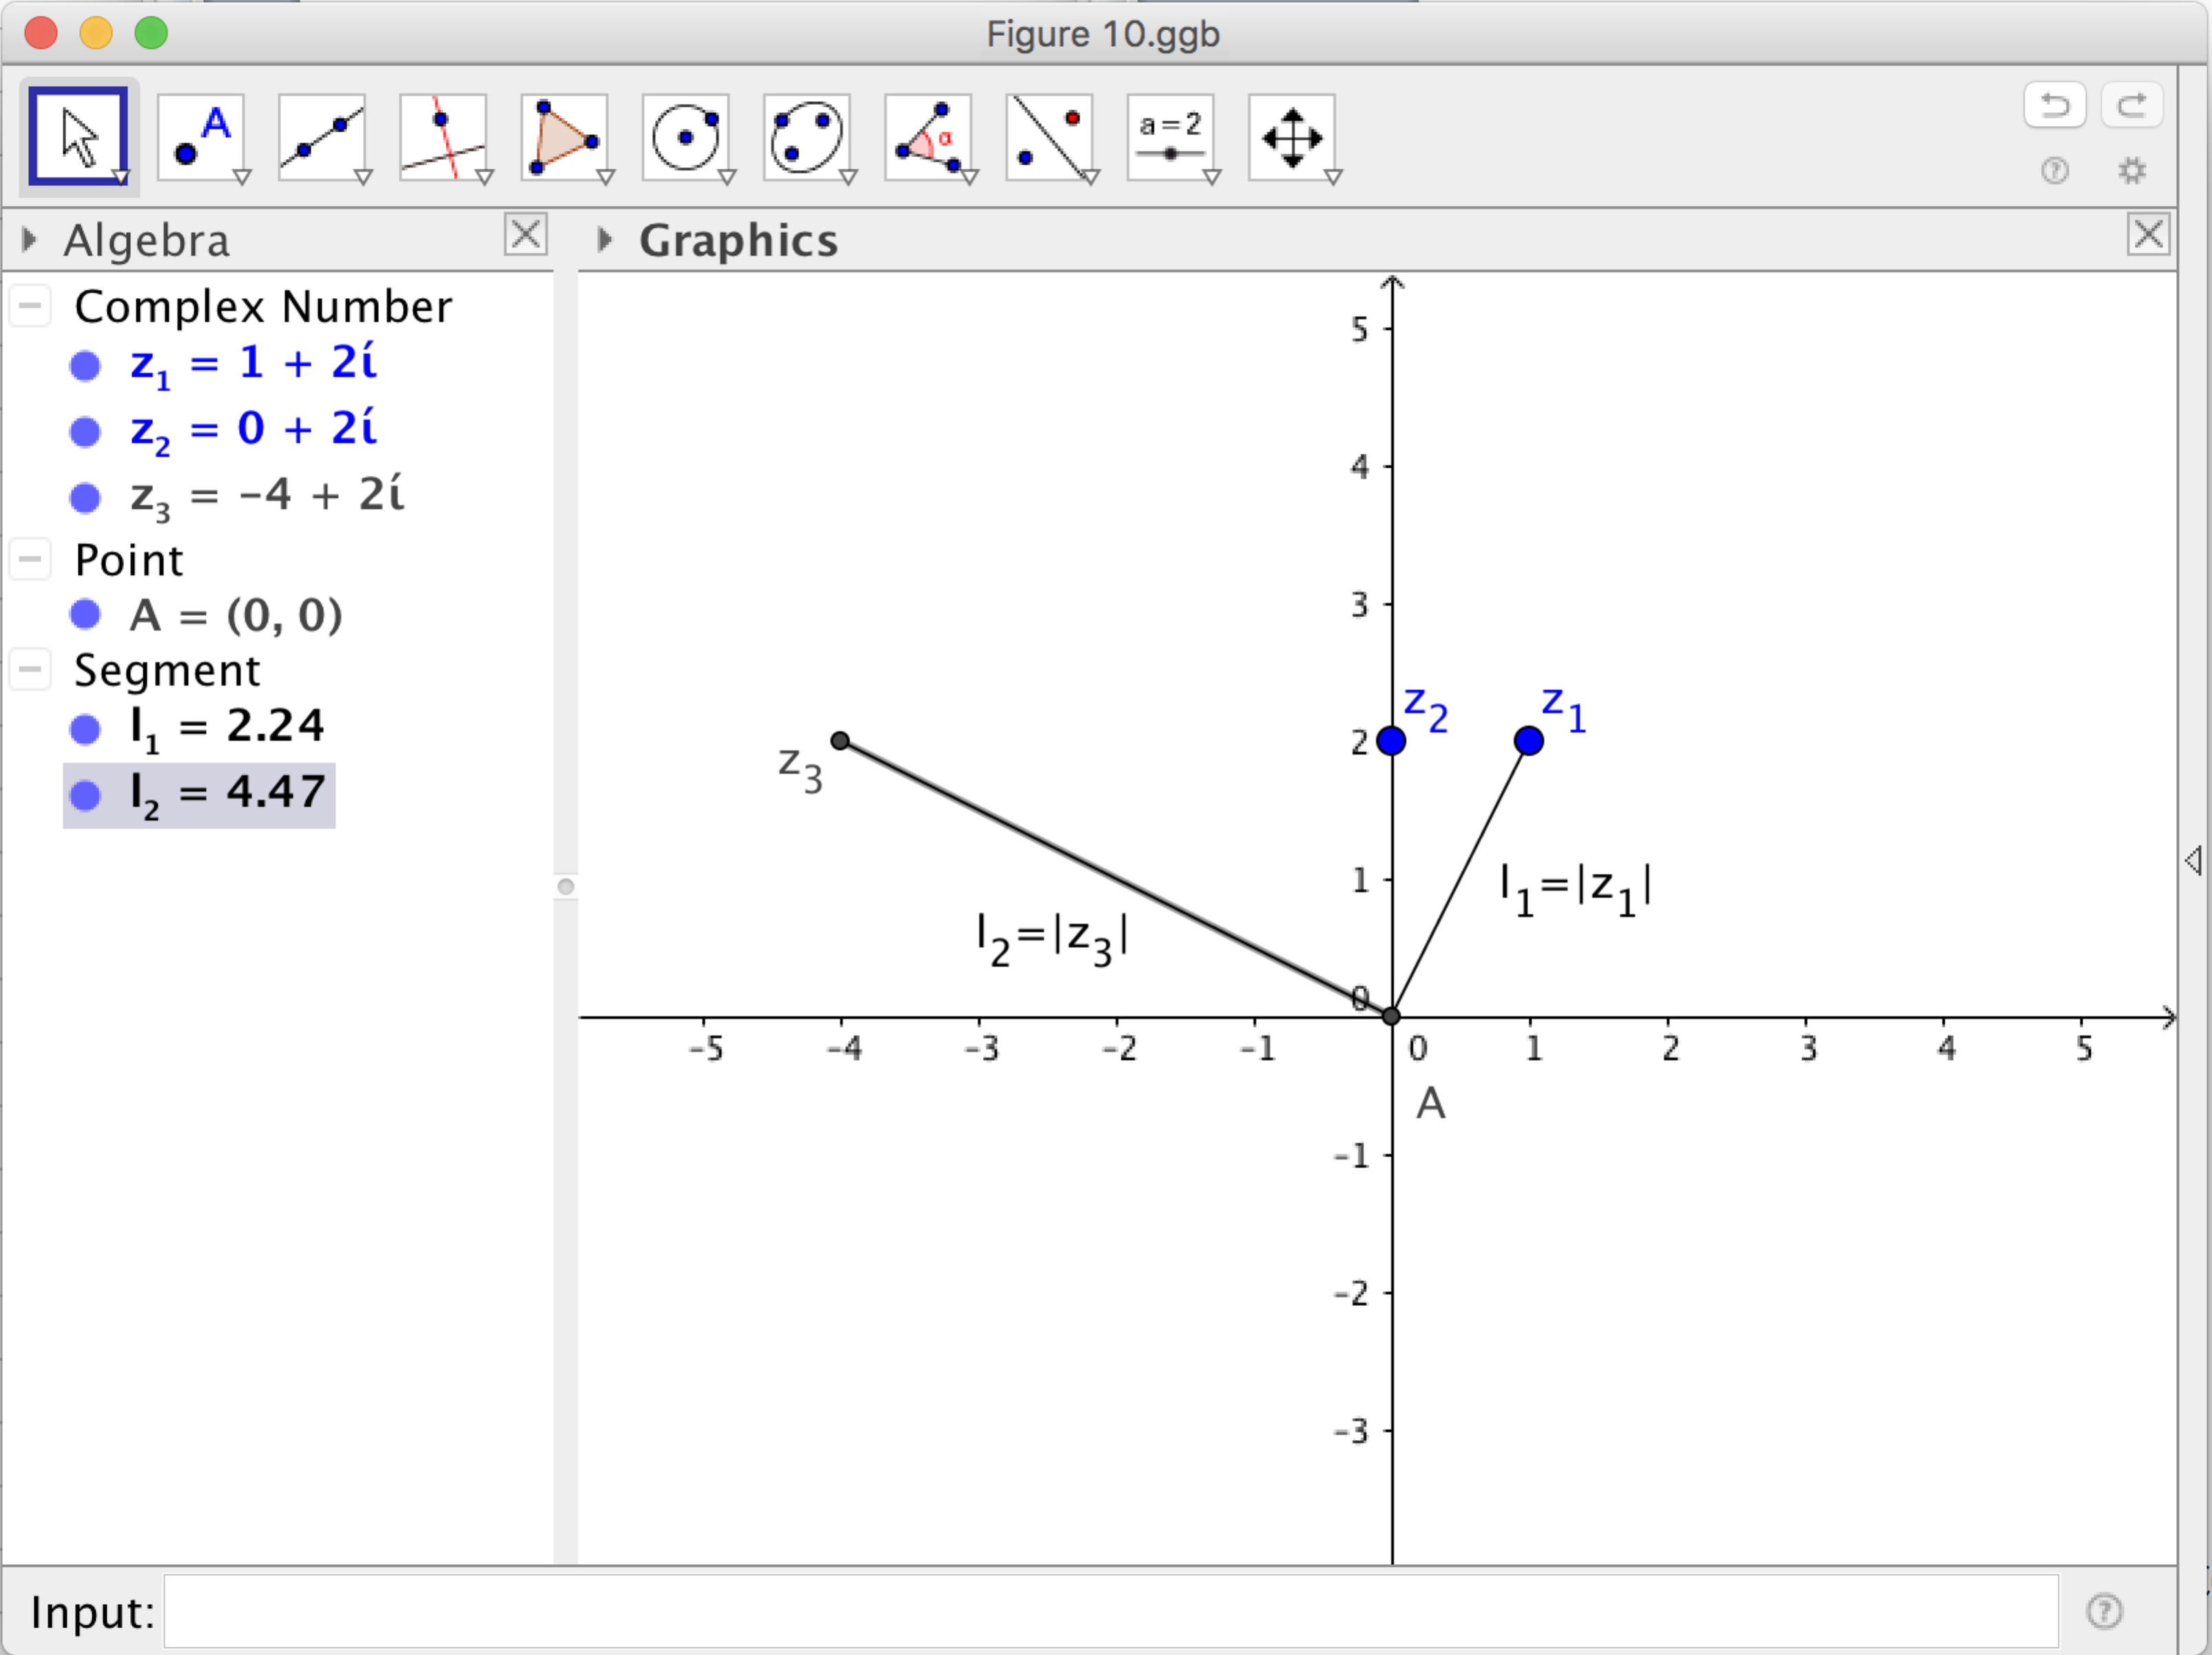
Figure 10 Multiplication of a complex number by 2i.
We again note that $z_{3}$is a 90° counterclockwise rotation of $z_{1}$ about the origin and that its modulus changes by a factor of $|z_{2}|$. Let’s move $z_{2}$ again – this time to the complex number $1+i$. If we consider the modulus of $z_{3}$ (construct the segment from the origin to $z_{3}$), the software displays about 1.44. Can you guess what this number is? Let’s compute the following ratio: $\frac{\left|z_{3}\right|}{\left|z_{1}\right|}$ (see Figure 11), by entering
ratio = l_2/l_1 in the Input box, where l_2 = |z_3| and l_1 = |z_1|.
Some readers may observe that
$$\frac{\left|z_{3}\right|}{\left|z_{1}\right|}≈\left|z_{2}\right|=\sqrt{2}.$$
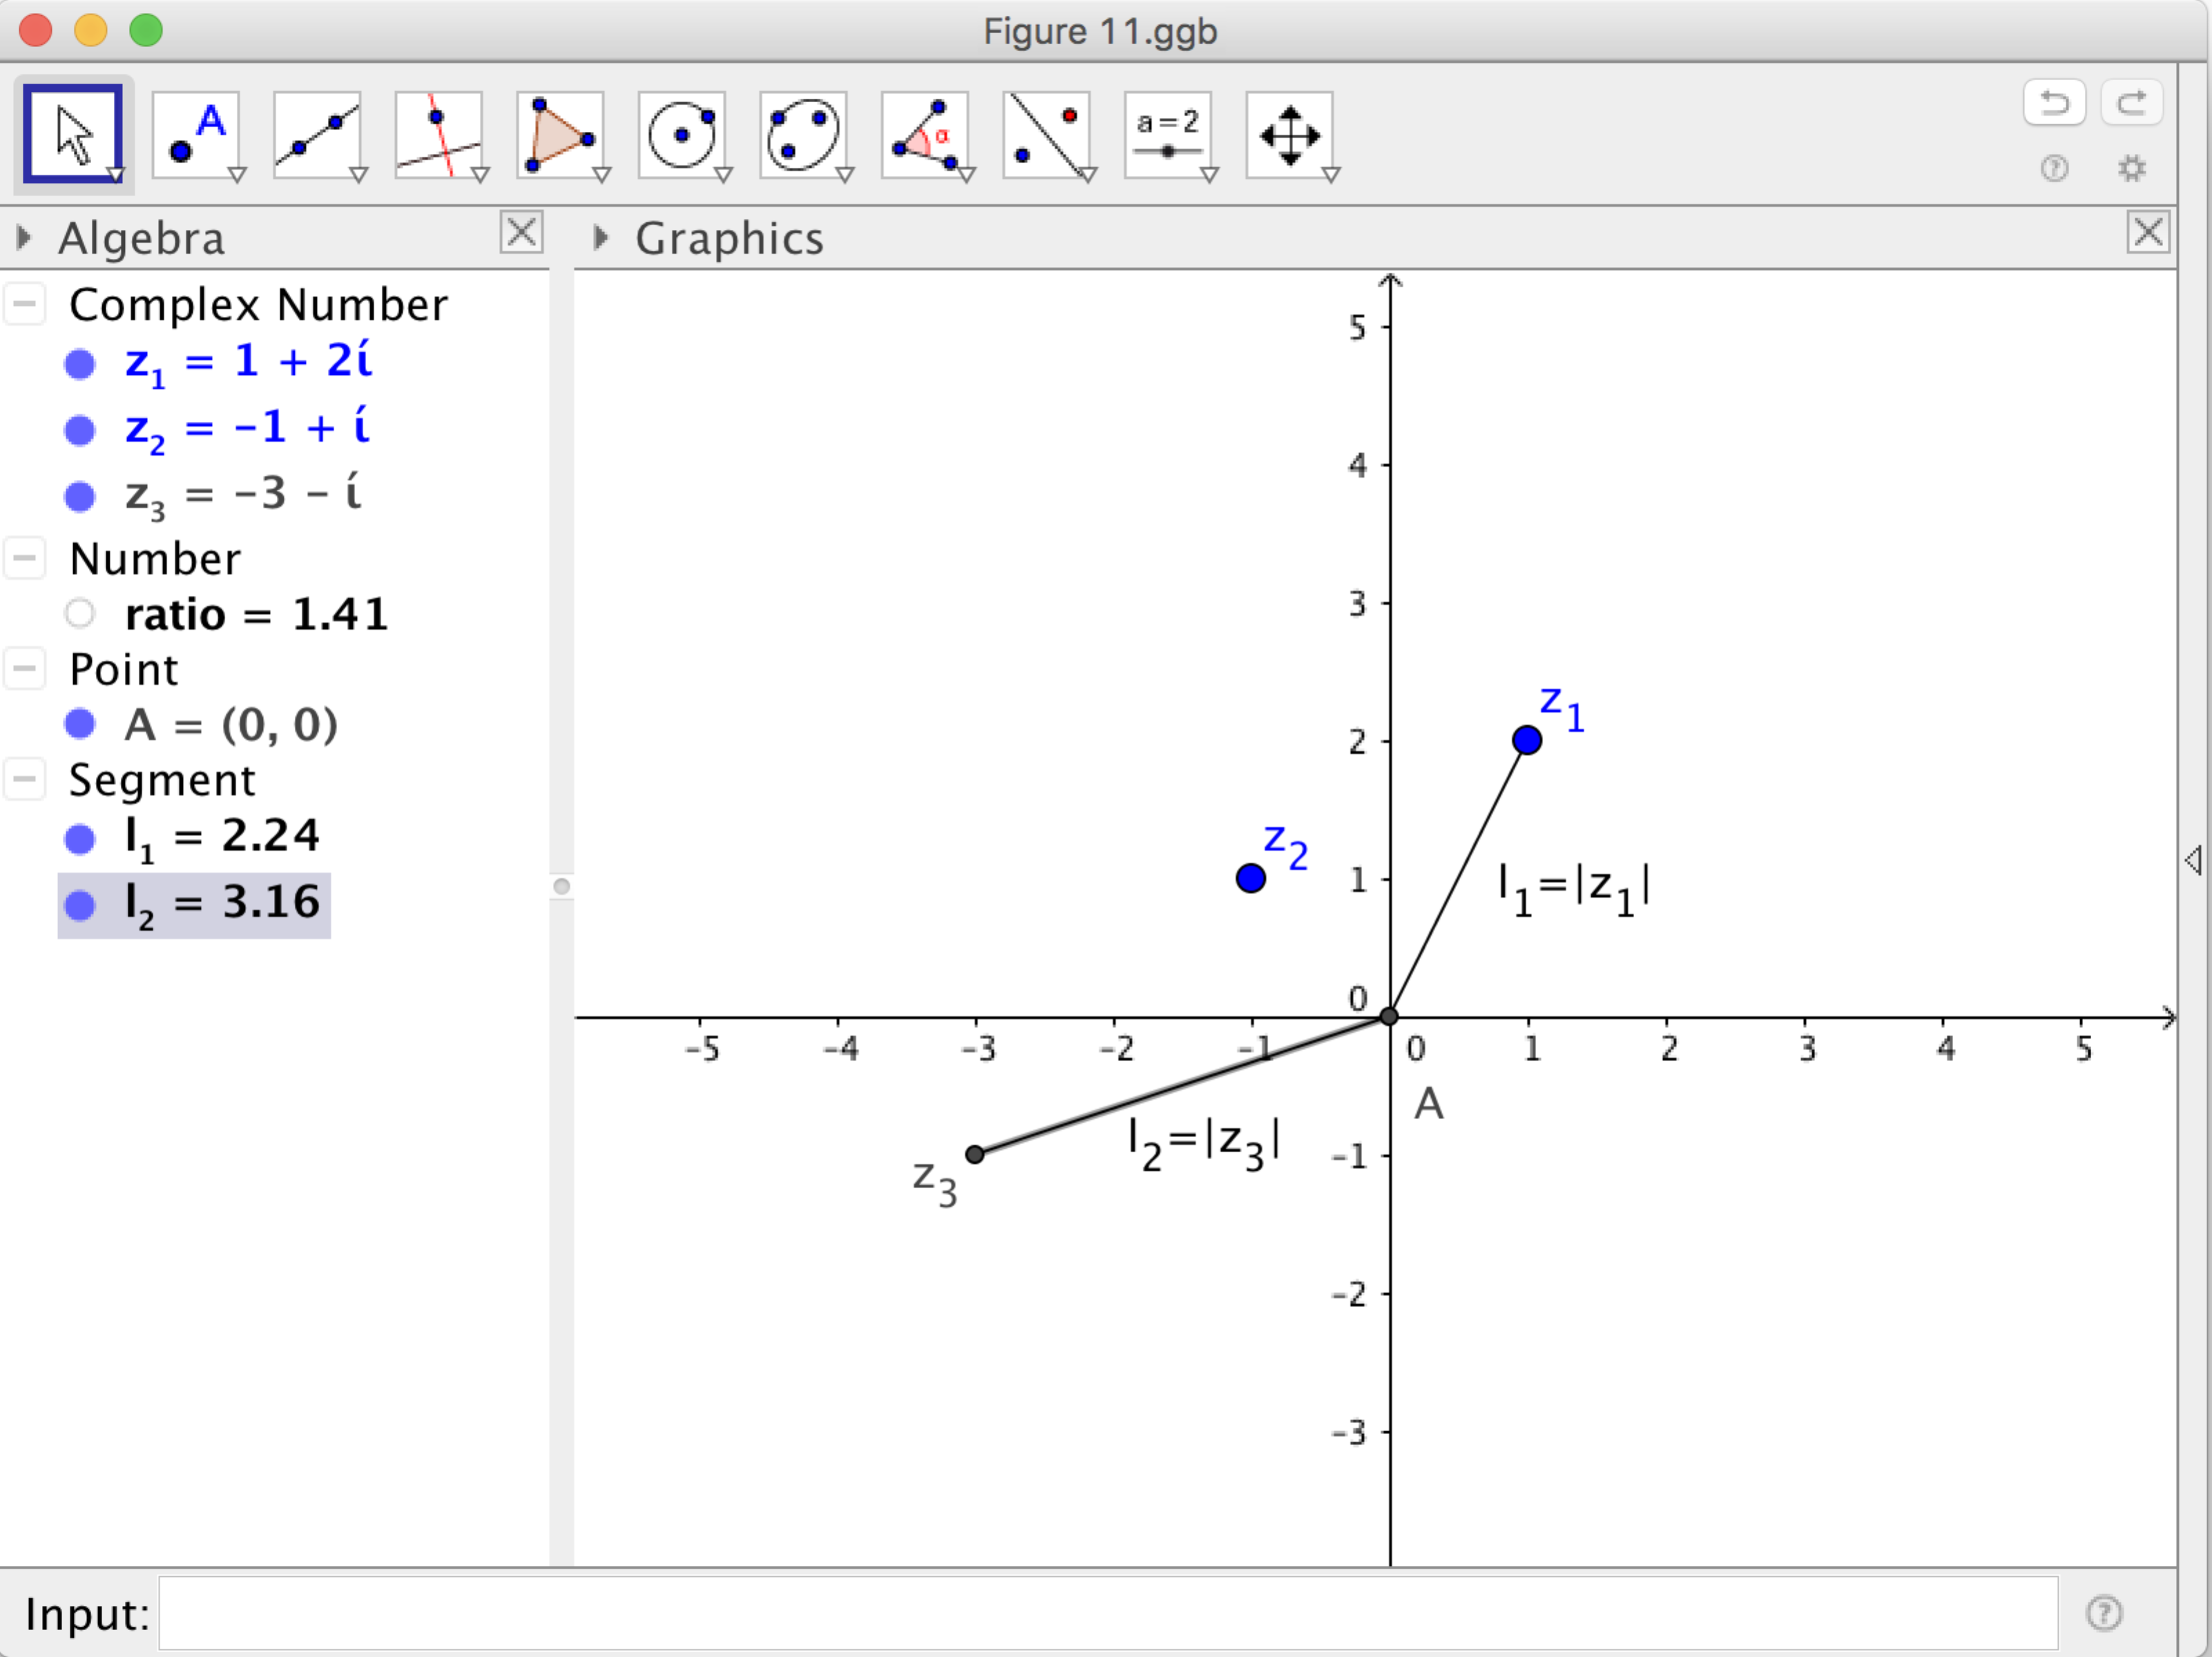
Figure 11 Multiplication of a complex number by $1+i.$

Is this true? If we move $z_{2}$ about the complex plane, is it always true that $\frac{\left|z_{3}\right|}{\left|z_{1}\right|}=\left|z_{2}\right|?$ This is a good time to recall the polar representation of a complex number $z=a+bi$. Namely, z can be represented as $z=r\left(\cos{θ}+i\sin{θ}\right),$ where $r=\sqrt{a^{2}+b^{2}}$ and $θ$ is the angle of the counterclockwise rotation about the origin from the point $(r,0)$ to the point $\left(a, b\right)$. The polar representation is particularly useful to compute the product of two complex numbers. The product of the complex numbers $z_{1}=r_{1}(\cos{θ_{1}}+i\sin{θ_{1}})$ and $z_{2}=r_{2}\left(\cos{θ_{2}}+i\sin{θ_{2}}\right)$ is given by:
$$z_{1}∙z_{2}=\left[r_{1}\left(\cos{θ_{1} }+i sin θ_{1}\right)\right]∙\left[r_{2}\left(\cos{θ_{2} }+i sin θ_{2}\right)\right]$$
$$=r_{1}∙r_{2}[\cos\left(θ_{1}+θ_{2}\right)+i sin {(θ}_{1}+θ_{2})].$$
In Figure 11 we have that $z_{3}=z_{1}∙z_{2}$, which is why the moduli of the product, $z_{3},$ is a dilation of the moduli of $z_{1}$ by a factor of $r_{2}$, and the angle of the rotation from $z_{1}$ to $z_{3}$ about the origin is $θ_{2}$. In our examples above, we can provide a mathematical justification of the 90° counterclockwise rotation about the origin and why the modulus of $z_{1}$ changes by a factor of $|z_{2}|$. Note that we can reverse the roles played by $z_{1}$ and $z_{2}$ in the above discussion due to the commutative property of multiplication. In the next section, we use complex number multiplication to rotate graphs. Again, we use the power of the locus tool to produce the resulting graph.
6 Rotation of a Graph using a Complex Number
Imagine that we want to rotate the graph of the function $f\left(x\right)=x^{2}$ by an angle of 45° counterclockwise about the origin. We now understand enough so that our initial idea might be to multiply the complex number $z=x+iy$ by the complex number $z_{1}=1+i$ since the argument of the complex number $z_{1}$ is 45°. Consider a complex number A with coordinates (x(A), y(A)), and multiply it by the complex number $1+i$ as follows:
$$\begin{matrix}\left[x\left(A\right)+iy\left(A\right)\right]∙\left[1+i\right] & = & x\left(A\right)+iy\left(A\right)+ix\left(A\right)-y\left(A\right) \\ - & = & \left[x\left(A\right)-y\left(A\right)\right]+i\left[x\left(A\right)+y\left(A\right)\right].\end{matrix}$$
Thus, to rotate a point A with coordinates (x(A), y(A)) on the graph of $f\left(x\right)=x^{2}$ we just need to apply the transformation $\left(x\left(A\right)-y\left(A\right),x\left(A\right)+y\left(A\right)\right)$. We now provide directions to do it with the software. Construct first the graph of $f\left(x\right)=x^{2}$. Next, construct a point A on the graph of $f\left(x\right)=x^{2}$. Type in the Input box the following command: B= (x(A) – y(A), x(A) + y(A)). Now to rotate the graph of $f\left(x\right)$, we use the Locus tool, clicking on B first and then on A. The software then creates the “desired” parabola (see Figure 12). Readers may notice that points A and B are not equidistant to the origin.
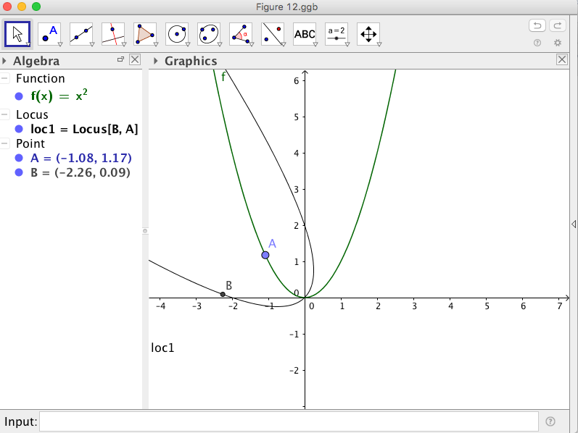
Figure 12 Initial attempt at rotating the graph of $f\left(x\right)=x^{2}$ by 45° counterclockwise using complex number multiplication.
We recall that the point B is not only a rotation of point A, but also a dilation by a factor of $\sqrt{2}=\left|1+i\right|.$ Thus our parabola is not only a rotation of $f\left(x\right)=x^{2}$ about the origin by 45° counterclockwise, but also a dilation by a factor of $\sqrt{2}$. How do we address this issue? We “normalize” our complex number $z_{1}$, that is we divide $z_{1}$ by $\sqrt{2},$ and use this new complex number to obtain the following transformation that is only a counterclockwise rotation about the origin by 45°:
$$\left(\frac{1}{\sqrt{2}}(x\left(A\right)-y\left(A\right)),\frac{1}{\sqrt{2}}(x\left(A\right)+y\left(A\right))\right)$$
Note that it is nearly impossible to tell the difference in the graphs in Figure 12 and Figure 13. If we look closely, we see that indeed there is a difference between the transformed graph in Figure 12 and the transformed graph in Figure 13. Note that the transformed graph in Figure 12 passes through the point
(0, 2) whereas the transformed graph in Figure 12 does not. Thus if we just want to rotate the graph by 45° we must normalize the number that we want to multiply by. This indeed can be a great way of introducing the idea of normalization before covering vectors. Again, we can easily redefine the function $f\left(x\right)$ in the Input box. Try $f\left(x\right)=\sin\left(x\right)$ and $f\left(x\right)= \frac{1}{x}$.

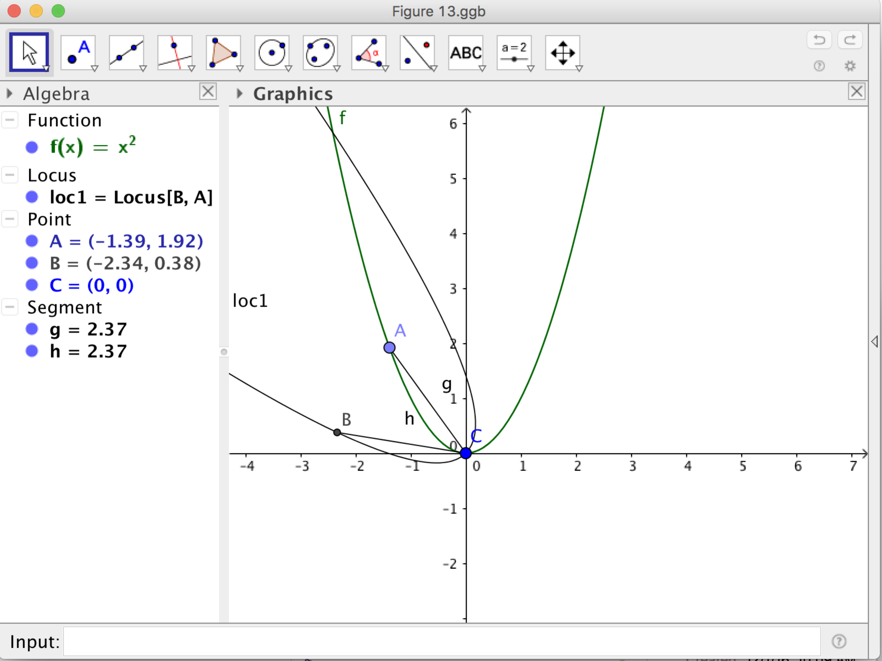
Figure 13 Rotating the graph of $f\left(x\right)=x^{2}$ by 45° counterclockwise using complex number multiplication.
7 Conclusions
In this paper, we have illustrated how dynamic geometry software can help us visualize and therefore connect complex numbers with their geometric interpretation. Specifically, we applied addition (subtraction) of complex numbers to translate objects, and multiplication of complex numbers to rotate and dilate objects. We invite readers to investigate the effect of dividing by a complex number. Another set of transformations to consider are reflections – if addition and subtraction of complex numbers are related to translations and multiplication and division of complex numbers are related to dilations and rotations, how are complex numbers related to reflections? We suggest to start by considering how complex numbers are related to reflections about the x- and y-axis.
We have presented these ideas to current and future secondary teachers either in classes or in professional development workshops. In general, teachers are able to perform complex number operations symbolically but when we ask them to describe the geometry of the operations they are usually able to connect addition with translations but do not appear to be familiar with a geometric interpretation of multiplication and division. In particular, teachers recognize how empowering the dynamic software is to help them visualize and understand formulas they have used.
Of course, a question that has been asked of us in the past is why this connection is considered important in the standards. To many this connection seems to not have any real-world or pedagogical benefits. We beg to differ as research suggests that multiple representations of mathematical concepts can develop a deeper understanding of the concept. Yet unknown to most, there is an application in the real world that can also serve as an introduction to the concepts of matrices and vectors. Indeed, this connection between algebra and geometry has led to many developments in image processing and understanding how complex numbers can be represented geometrically can help in gaining a basic understanding of these developments. In a paper in progress, we discuss such a relationship between matrices, transformations, complex numbers, and applications.
We hope that our work contributes to implementing the Standards for Mathematical Practice (SMP) recommended by the CCSS-M, especially SMP 5, Using appropriate tools strategically, SMP 7, Look for and make use of structure, and SMP 8, Look for and express regularity in repeated reasoning.
References
- Common Core State Standards Initiative (CCSSI). 2010. Common Core State Standards for Mathematics. Washington, DC: National Governors Association Center for Best Practices and the Council of Chief State School Officers. URL http://www.corestandards.org/wp-content/uploads/Math_Standards.pdf.
- Dunham, William. 1990. Journey through genius: the great theorems of mathematics. New York: Wiley.
- Hohenwarter, Markus. 200x. Geogebra. Free download at URL https://www.geogebra.org/download/.
- Hollingdale, Stuart. 1989. Makers of mathematics. London, England: Penguin Books.

